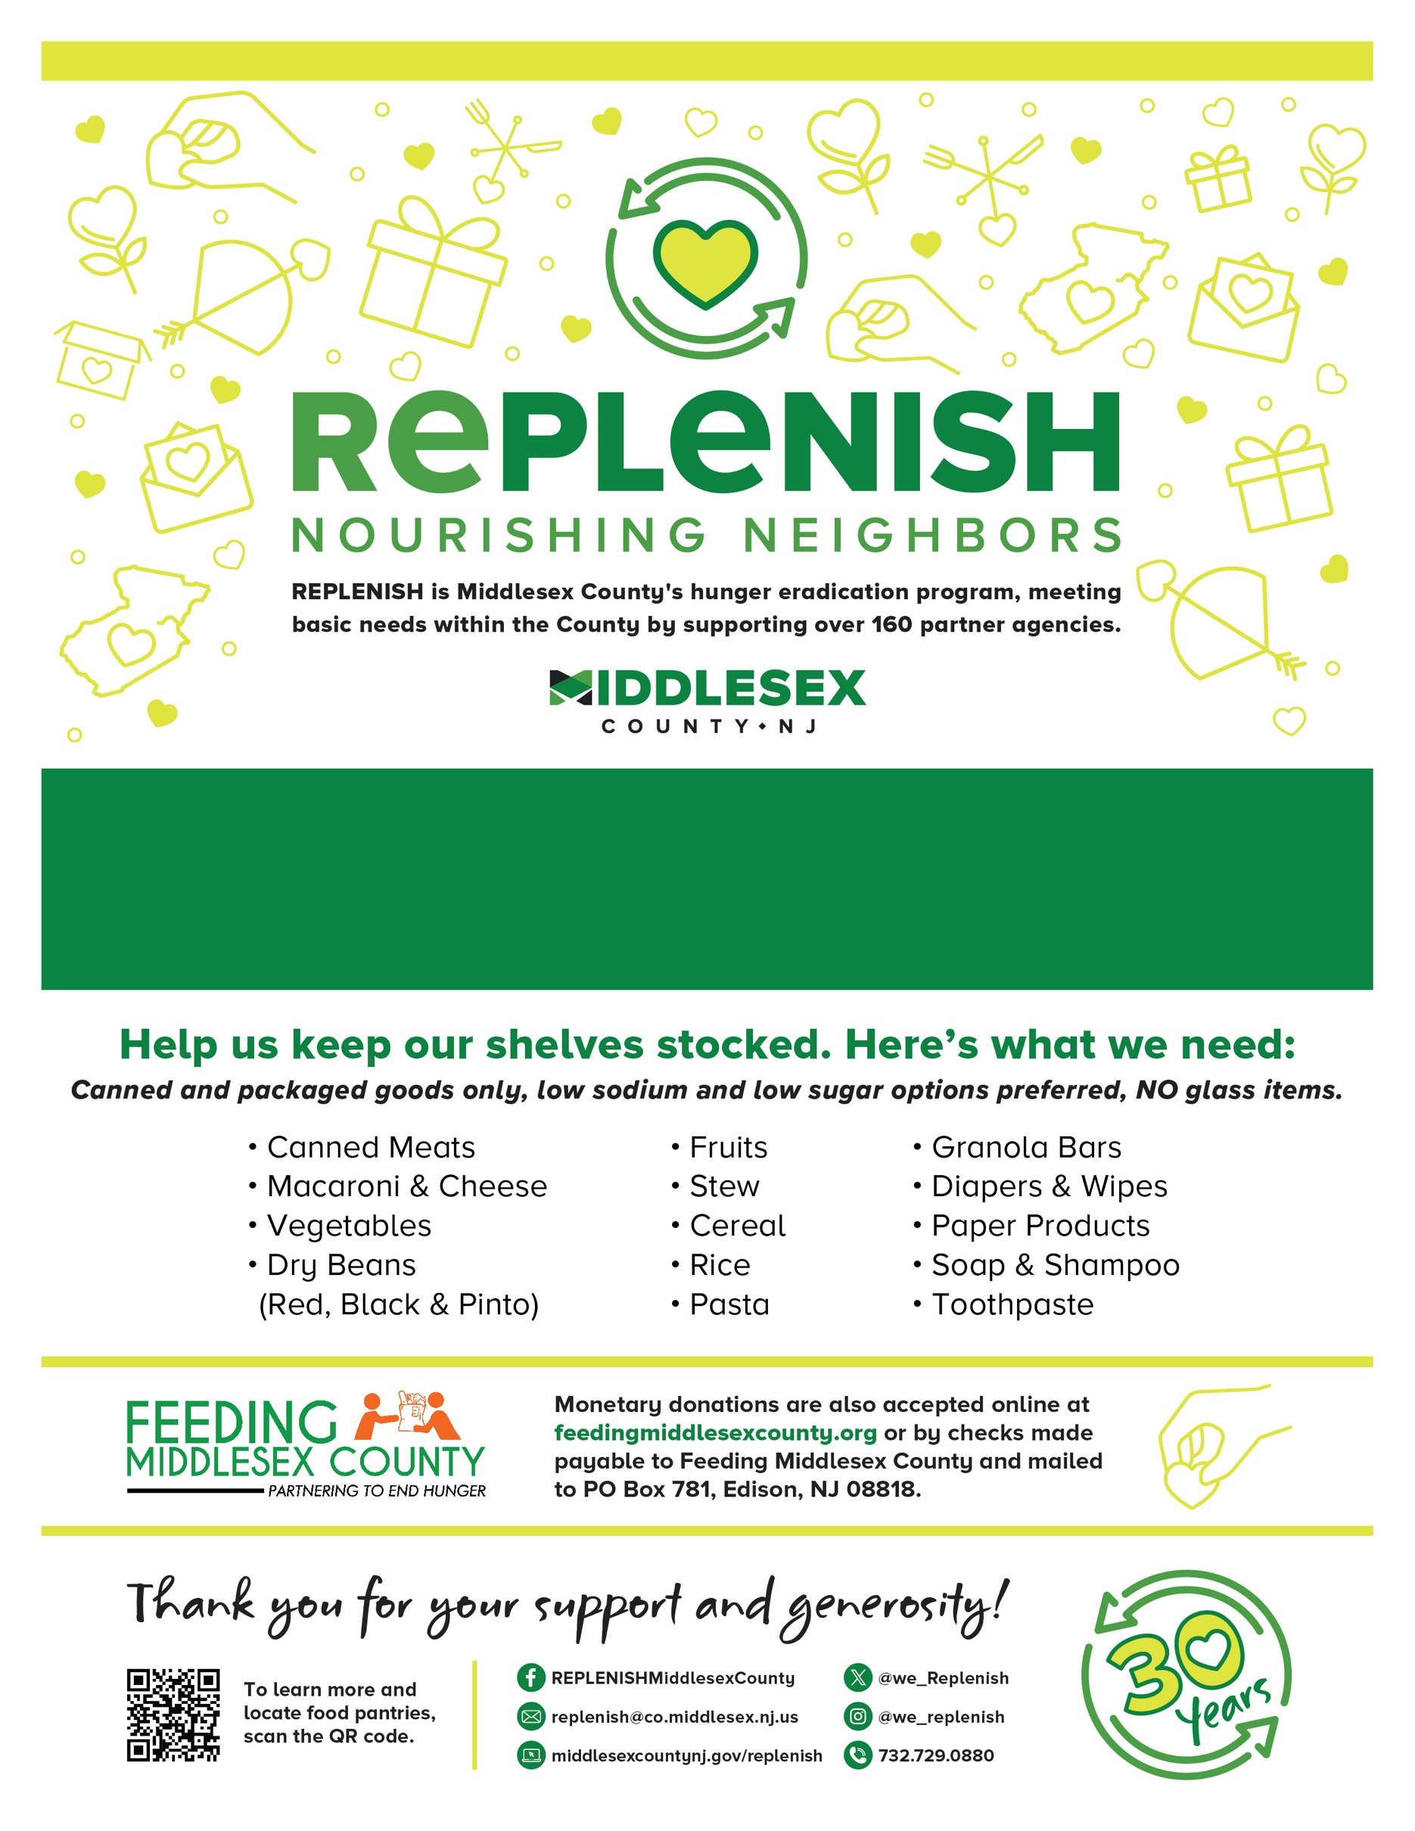

**Name of Food Drive**

Address, Municipality or Location

**Day, Date / Time**