**MIDDLESEX COUNTY HOMELESS TRUST FUND**

APPLICATION FOR FY2024 MIDDLESEX COUNTY HOMELESS TRUST FUND (MCHTF) FUNDING

Agency Name: ___________________________________________________

Agency Address: _________________________________________________

________________________________________________________________

Agency Executive Director: _________________________________________

Telephone: _____________________ Email: _________________________

Project Name: ___________________________________________________

Project Address: _________________________________________________

_______________________________________________________________

Project Contact Person & Title: ______________________________________

Telephone: _____________________ Email: __________________________

Description of Proposed Project & Timeline: ____________________________

________________________________________________________________

________________________________________________________________

________________________________________________________________

Total Cost of Project $______________

Requested MCHTF Funding: $_____________

LIST Middlesex County Homeless Trust Fund (MCHTF) Priority this Project addresses: _____________________________________

(Priorities are included in the Application Packet)

**Please provide succinct answers to the following questions.**

1. Please indicate which of the following the program is intended to benefit:

* Homeless individuals, regardless of gender
* Individual Homeless males
* Individual Homeless females
* Homeless families
* Other (i.e. Victims of Domestic Violence, Homeless Seniors, Homeless Youth, etc.) ________________________

1. Please indicate how many people in total the program intends to serve annually. Support your answer with empirical data.
2. Please state your organization’s experience working with this population.
3. Please explain how, and with whom, you intend, through this program, to collaborate and coordinate with other providers of homelessness services in the County. This can include but is not limited to MCHC3, Consumer Participation Committee, Homeless Youth Task Force and the Youth Action Board.
4. Explain why receipt of funding from the Middlesex County Homeless Trust Fund (MCHTF) is essential to the success of this project/program.
5. What other funding have you applied for?
6. How would you reduce the scope of this project/program if you did not receive full funding?
7. If possible, set forth discrete phases in which the project/program can be completed.
8. If this is a new program, what is the anticipated operational date of the program?

**Middlesex County Homeless Trust Fund** **FUNDING application deadline:**

Return this application by **4:00PM on September 10,2024** to:

**Michelle Grabelle, Homeless Programs Supervisor**

**Michelle.Grabelle@co.middlesex.nj.us**

**GLOSSARY OF TERMS**

**Inputs** are resources a program uses to achieve program objectives. Examples are staff, volunteers, facilities, equipment, curricula, and money.

A program uses *inputs* to support activities*.*

**Activities** are what a program does with its inputs – the services it provides – to fulfill its mission.

Examples are sheltering homeless families, educating the public about signs of child abuse, and providing adult mentors for your program. Program *activities* result in *outputs*.

**Outputs** are products of a program’s activities, such as the number of meals provided, classes taught, brochures distributed, or participants served. Another term for “outputs” is “units of service.” A program’s *outputs* should produce desired *outcomes* for the program’s participants.

**Outcomes** are benefits for participants during or after their involvement with a program. Outcomes may relate to knowledge, skills, attitudes, values, behavior, condition, or status.

Examples of outcomes include greater knowledge of nutritional needs, improved reading skills, more effective responses to conflict, getting a job, and having greater financial stability.

For a particular program, there can be various “levels” of outcomes, with initial outcomes leading to longer-term ones. For example, a youth in a mentoring program who receives one-to-one encouragement to improve academic performance may attend school more regularly, which can lead to getting better grades, which can lead to graduating.

**Goals**: A goal is what you intend to do, **or** what you strive to do, **or** what you want to do **or** what you want to achieve.

Example: my goal is to lose 10 pounds by September 30, 2011 (this is what I hope, strive, intend, and plan to do).

**“Program goals describe outcomes a program wishes to achieve”. Source:**

**Online Library**

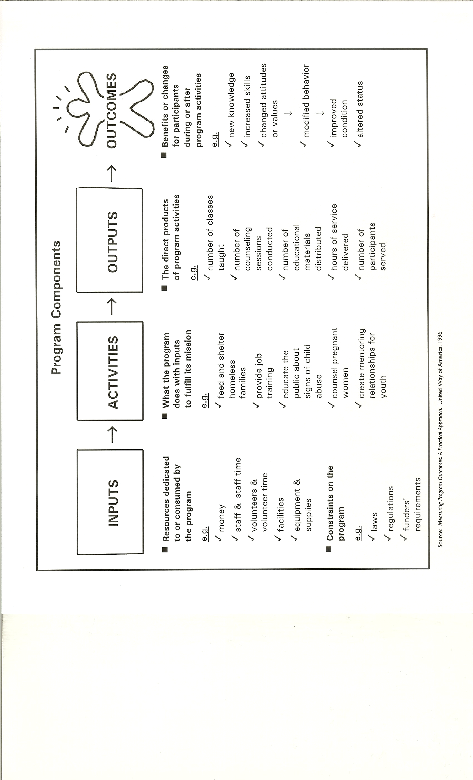

**SUMMARY OF YOUR PROGRAM OUTCOME MODEL**

For component descriptions and glossary terms please see **pages 4 & 5**

|  |  |  |  |
| --- | --- | --- | --- |
| **Inputs** | **Activities** | **Outputs** | **Outcomes** |
|  |  |  |  |

|  |  |
| --- | --- |
|  | |
| **AGENCY CERTIFICATION**  Please check each eligibility below to indicate the organization’s commitment and ability to fulfill the requirements.  (***If there is no check off, please explain.)*** | |
|  |  |
|  | As a Not-For-Profit applicant, has Articles of Incorporation and exemptions from Federal income tax under Section 501c(3) or is exempt from taxation under another section of the IRS Code. |
|  | Has current Board of Directors list with terms of office and minutes of the last six Board meetings. |
|  | Has most recent annual certified audit or financial statements and annual report. |
|  | Has IRS Form 990 or 990EZ. |
|  | Has current Strategic Plan. |
|  | Has stated policies of nondiscrimination and complies with all the requirements of state and Federal laws and regulations on nondiscrimination and equal opportunity with respect to clients, officers, employees, and volunteers. |
|  | Does not knowingly employ individuals or contribute funds to organizations found on terrorist-related lists officially announced by the US Government, the United Nations or the European Union. |
|  | Can submit certification to Middlesex County indicating compliance with the spirit and intent of the USA Patriot Act and other counterterrorism laws as requested. |
|  | Has a demonstrated expertise with the initiative or program covered on the Proposal. |
|  | Has ability to identify and to measure outcomes and report results and cooperation in an outcome measurement process. |
|  | Has current copies of Licensure or Accreditation (if applicable). |
|  | Board has approved applying for these funds and agrees to enter into a contract with Middlesex County Board of Chosen Freeholders and all the provisions of said contract. |
|  | If funding is approved, agency either participates in or is willing to participate in HMIS (Homeless Management Information System). |

**EXECUTIVE DIRECTOR: ______________________________________ DATE: _________________**

**CHAIRPERSON/BOARD PRESIDENT: ______________________________________________ DATE: _________________**